OCTANET – WEB DEVELOPMENT INTERN

TASK –1

NAME:S.MADHURI

**TASK:** Create and Design Landing page.

The goal of this project is to create a Landing Page project, you have the creative freedom to choose a design and theme that resonates with you. The goal is to develop a landing page for an event or launch, which could be related to a variety of course introduction.

**Technologies Used:**

For a course introduction landing page project, you can leverage a variety of technologies to create a compelling and user- friendly experience. Here are some commonly used technologies:

* **HTML/CSS**: These are the building blocks of web development. HTML is used for structuring the content of the landing page, while CSS is used for styling and layout.
* **JavaScript**: JavaScript can be used to add interactivity and dynamic elements to the landing page, such as animations, form validation, and interactive elements like sliders or accordions.
* **Bootstrap or other CSS frameworks**: Frameworks like Bootstrap provide pre-designed components and responsive layout grids, making it easier to create a visually appealing and mobile-friendly landing page.
* **Frontend JavaScript libraries**: Libraries like React.js or Vue.js can be used to build interactive user interfaces

and manage state more efficiently, especially for more complex landing page designs.

By leveraging these technologies effectively, you can create a dynamic, visually appealing, and user-friendly course introduction landing page that effectively communicates the value of your course and encourages users to enroll.

**REFERENCE DESIGN**

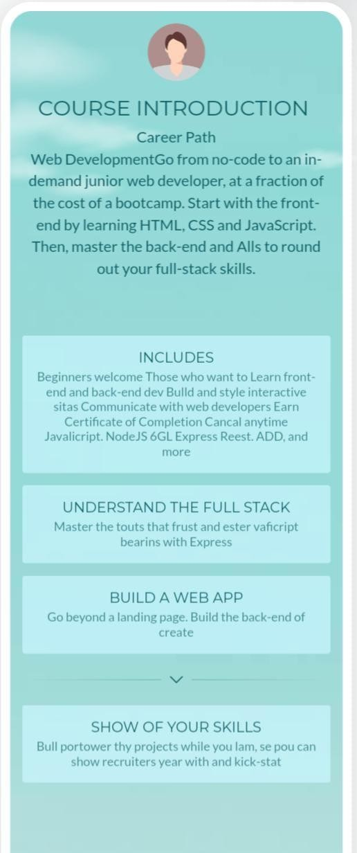

**JAVASCRIPT CODE**

<!DOCTYPE html>

<html lang="en">

<head>

<meta charset="UTF-8">

<meta name="viewport" content="width=device-width, initial-scale=1.0">

<title>Course Introduction Landing Page</title>

<link rel="stylesheet" href="styles.css">

</head>

<body>

<header>

<h1>Welcome to Our Course</h1>

<p>Learn and Grow with Us!</p>

</header>

<section class="course-info">

<h2>About the Course</h2>

<p>This course covers a range of topics including HTML, CSS, and JavaScript. It is designed for beginners who want to learn web development.</p>

<ul>

<li>Duration: 8 weeks</li>

<li>Format: Online</li>

<li>Price: $99</li>

</ul>

<a href="#enrollment" class="cta-button">Enroll Now</a>

</section>

<section id="instructor" class="instructor-info">

<h2>About the Instructor</h2>

<img src="instructor.jpg" alt="Instructor Photo">

<h3>John Doe</h3>

<p>John is a seasoned web developer with over 10 years of experience. He is passionate about teaching and helping others learn.</p>

</section>

<section id="enrollment" class="enrollment-info">

<h2>Enrollment</h2>

<p>Ready to get started? Enroll now to secure your spot!</p>

<form id="enrollment-form" action="enroll.php" method="POST">

<input type="text" id="name" name="name" placeholder="Your Name" required>

<input type="email" id="email" name="email" placeholder="Your Email" required>

<button type="submit">Enroll</button>

</form>

</section>

<footer>

<p>&copy; 2024 Course Introduction Landing Page</p>

</footer>

<script>

// Smooth scrolling to section when clicking on CTA button document.querySelector('.cta-button').addEventListener('click', function(e) { e.preventDefault();

const targetSection = document.querySelector(this.getAttribute('href')); targetSection.scrollIntoView({ behavior: 'smooth' });

});

</script>

</body>

</html>